# **Project 0. Setting Up Virtual Machines**

Set up the following:

* VirtualBox: https://www.virtualbox.org//wiki/Downloads
* pfSense: https://www.pfsense.org/download/
* Metasploitable: https://sourceforge.net/projects/metasploitable/
* Kali Linux: https://www.offensive-security.com/kali-linux-vmvmware-virtualbox-image-download

## PFSense Set Up:

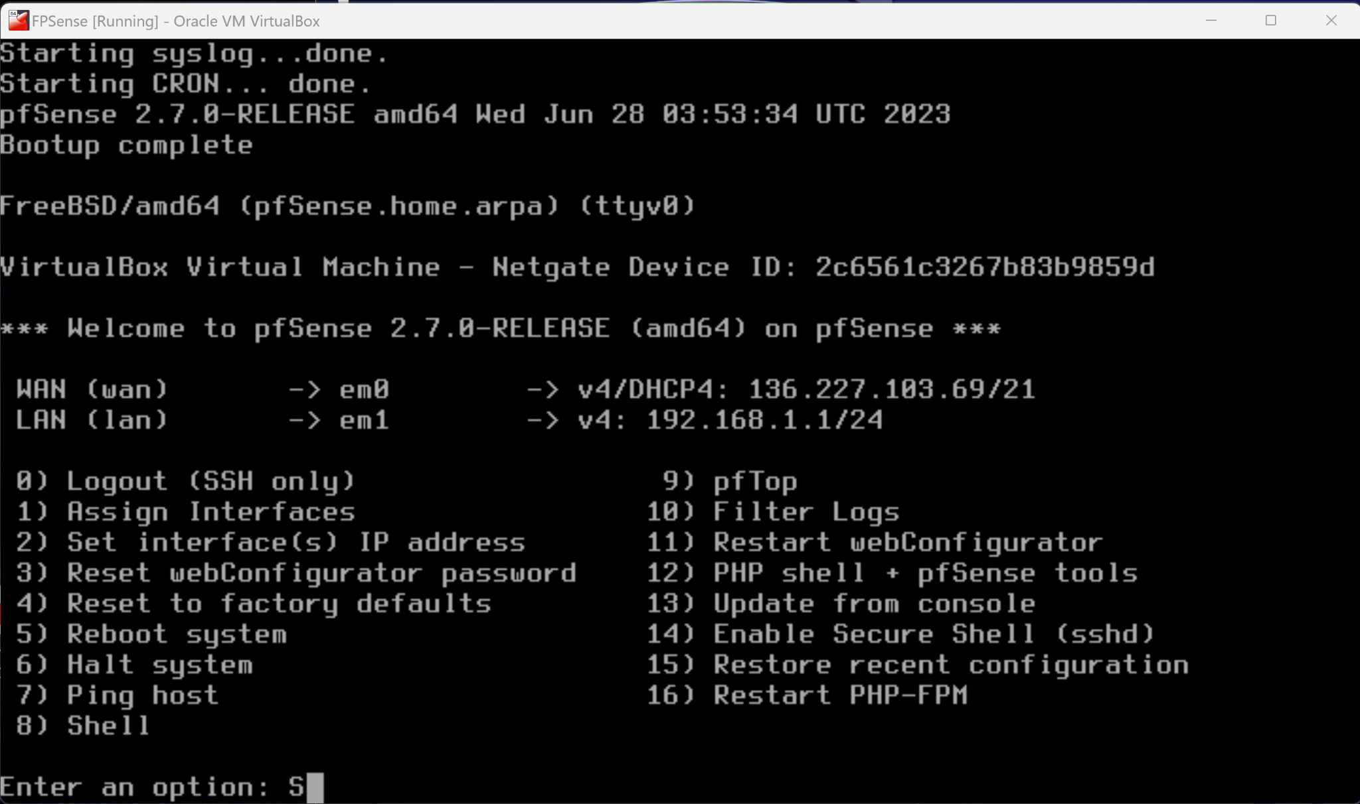

Metasploitabe Set Up:

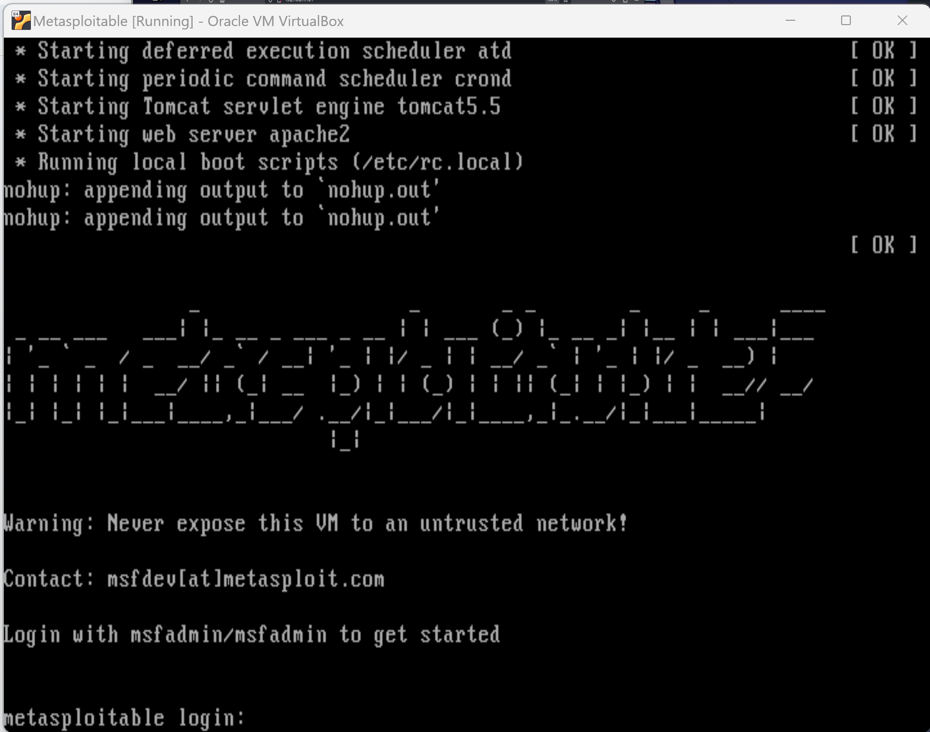

Kali Linux Set Up & Connected to Metasloitable through pfSense:

Step 1: Run the netdiscover command.

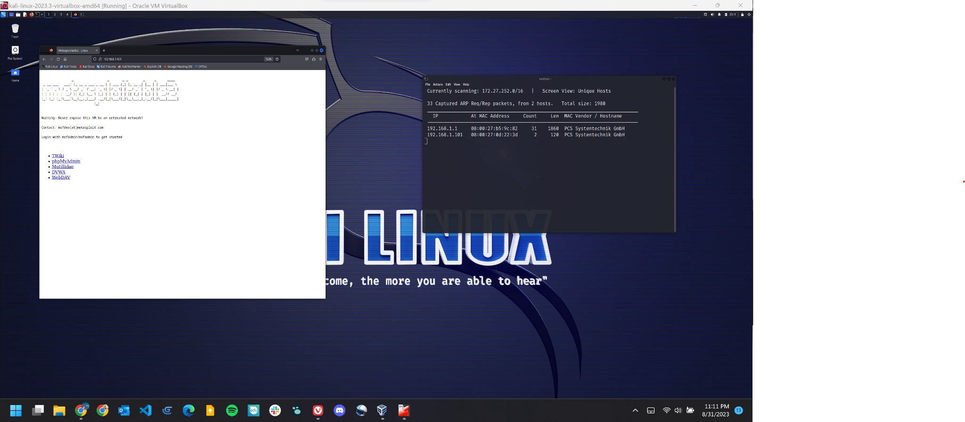

**Step 2:** Connect to Metaspoitabe using the known user and password hack.



**Step 3:** Communicate through FTP and run commands to confirm a connection.

